City of Bastrop Permit Requirements

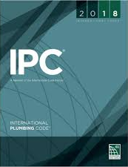

International Plumbing Code (IPC)

106.1 Where required.
Any owner, owner’s authorized agent or contractor who desires to construct, enlarge, alter, repair, move, demolish or change the occupancy of a building or structure, or to erect, install, enlarge, alter, repair, remove, convert or replace any plumbing system, the installation of which is regulated by this code, or to cause any such work to be performed, shall first make application to the code official and obtain the required permit for the work.

106.2 Exempt work.
The following work shall be exempt from the requirement for a permit:
- The stopping of leaks in drains, water, soil, waste or vent pipe provided, however, that if any concealed trap, drainpipe, water, soil, waste or vent pipe becomes defective and it becomes necessary to remove and replace the same with new material, such work shall be considered as new work and a permit shall be obtained and inspection made as provided in this code. (IBC, IRC)
- The clearing of stoppages or the repairing of leaks in pipes, valves or fixtures, and the removal and reinstallation of water closets, provided that such repairs do not involve or require the replacement or rearrangement of valves, pipes or fixtures. (IBC, IRC)

*Exemption from the permit requirements of this code shall not be deemed to grant authorization for any work to be done in violation of the provisions of this code or any other laws or ordinances of this jurisdiction.

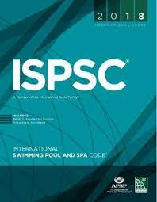

International Swimming Pool and Spa Code (ISPSC)

105.1 When required.
Any owner, or owner’s authorized agent who desires to construct, enlarge, alter, repair, move, or demolish a pool or spa or to erect, install, enlarge, alter, repair, remove, convert or replace any system, the installation of which is regulated by this code, or to cause any such work to be performed, shall first make application to the code official and obtain the required permit for the work.

